**PET APPOINTMENT AND VETERINARY RECORD SYSTEM FOR PETLANDIA IN MALOLOS CITY BULACAN**

A Thesis Project Presented to the

Faculty of Datamex College of Saint Adeline, Inc.

In Partial Fulfillment of the Requirements for the

Degree of Bachelor of Science in Information Technology

By:

Amponin, Alexis John

Ausa, Justin

Dueñas, Jhaze

Geronimo, Reymark

September 15, 2025

**DESIGN**

**DOCUMENT**

**INTRODUCTION**

The purpose of this document is to present the design of the Pet Appointment System. This system is made to help veterinary clinics and pet care centers manage appointments in a simple, accurate, and organized way. Many clinics today still use manual methods such as writing in notebooks or paper records. This approach is slow, prone to errors, and can cause confusion when the number of clients grows. By creating a computer-based system, the process of scheduling, viewing, and updating appointments will become easier and faster. This document will explain the overall design of the system, including its features, architecture, and security. It will serve as a guide for the users, and other stakeholders to understand how the system works and what benefits it brings. It will also provide the foundation for future improvements and updates that may be needed as the clinic grows or as technology changes.

The Pet Appointment System is a computer-based solution that allows pet owners to schedule appointments for their pets without difficulty. The system will store all appointment details in a secure database, which can be easily accessed and managed by the clinic staff. Instead of relying on papers that can be lost or damaged, the system ensures that all records are safe and organized. The system is designed to provide several important functions. First, it allows the registration of pet owners and their pets. Second, it provides a scheduling function where appointments can be set, viewed, updated, or canceled. Third, it generates a clear list of daily or weekly appointments so the staff can prepare ahead of time. Lastly, it ensures that the information is accurate, reliable, and available whenever needed. With the help of this system, pet owners will no longer need to wait in long lines just to secure an appointment. They can be assured that their pets will receive proper attention on the scheduled date. On the other hand, the clinic staff will benefit from reduced workload, fewer errors, and better time management.

This design document will explain the important aspects of the Pet Appointment System. It will cover the system architecture, including the main components and how they interact with each other. In addition, the document will

include the user interface design, showing how the system will look and how users will interact with it. The component design section will describe the key parts of the system and how they will work together. Data flow diagrams will also be presented to illustrate how data moves through the system. Finally, the document will cover the security design, explaining how the system will protect sensitive information and ensure that only authorized users can access the data.

**System Architecture**

The Pet Appointment System is designed using a client-server architecture. This means that the users, such as pet owners and clinic staff, interact with the system through a client application, while the main processing and storage of data happen in the server. The system ensures that all information is processed efficiently and stored securely in the database.

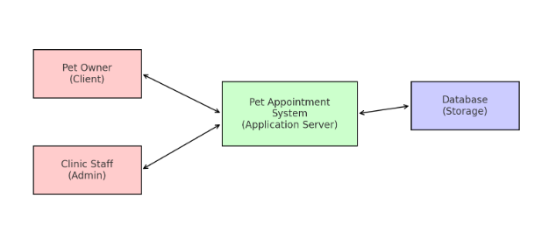

*Figure 1. System Architecture of Pet Appointment System*

These components interact in the following way: Pet owners or staff send requests from the client side. The application server processes these requests and communicates with the database to either retrieve or update information. The processed data is then sent back to the client.

The system can be deployed in two ways:

* Stand-Alone System – The application will be set up and used on one local computer inside the veterinary clinic office. It can work without needing an internet connection, making it dependable even if there are network issues.
* Offline Capability – The system will still operate normally without internet. All tasks and records are handled and saved directly on the computer.

Communication Protocols and Interfaces:

Protocols

* The system uses XAMPP commands to manage the sending and receiving of data between the program and the database.
* All information is stored and transferred directly on the local computer, which makes the process faster and keeps the system safe even without an internet connection.

Interface

* The system provides separate user interfaces for administrators, staff, and pet owners, each with role-based access to make sure sensitive data is protected.
* The interface is built to be simple and easy to use, allowing clinic staff to schedule and manage appointments, update records, and view reports quickly and efficiently.
* Pet owners have a dedicated interface where they can register their pets, book appointments, and check schedules with ease.
* Administrators have **full control,** including managing staff accounts, monitoring system activities, and maintaining data security.

**USER INTERFACE DESIGN**

**Admin Interface Design**

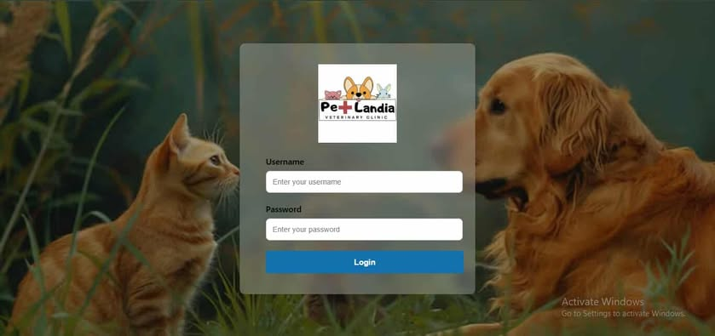1.The log-in screen is the entry point of the Pet Appointment System. It requires users to enter their username and password before accessing the system. This ensures that only authorized administrators, and staff can securely log in. Through this screen, administrators and staff can manage appointments, pet records, and reports.

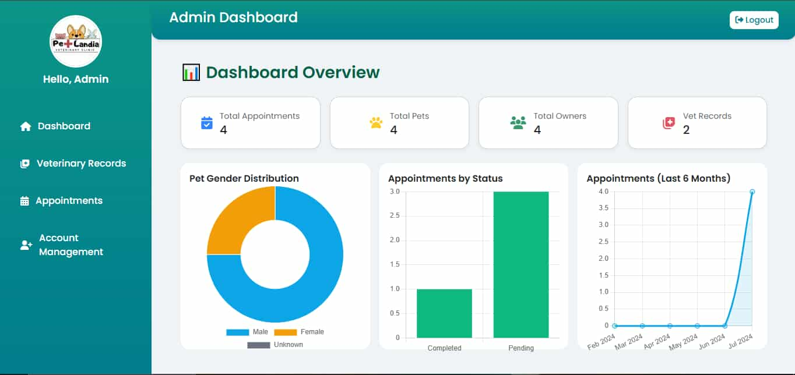2.The Admin Dashboard is the main screen of the Pet Appointment and Veterinary Record System. It provides an overview of important information such as the total number of appointments, pets, owners, and veterinary records. It also displays graphical statistics showing pet gender distribution, appointment status, and appointment trends over the last six months. This dashboard helps the admin easily monitor clinic activities, track performance, and manage operations efficiently in real time.

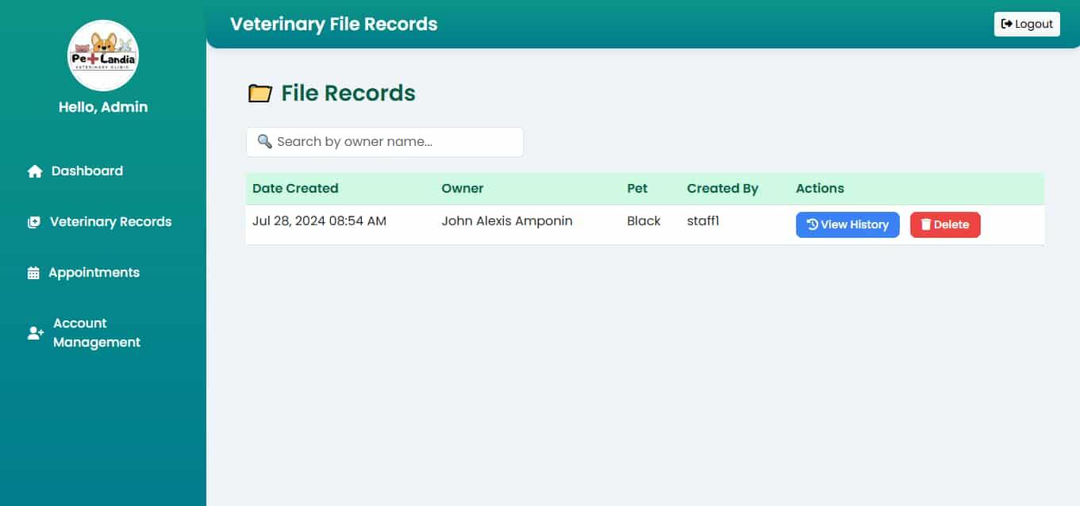3.The Veterinary File Records page allows the admin to view and manage all veterinary records of pets. It displays details such as the date created, owner name, pet name, and the staff who added the record. The admin can also search for specific records by owner name and perform actions like viewing history or deleting records. This feature ensures that pet medical information is organized, accessible, and properly maintained.

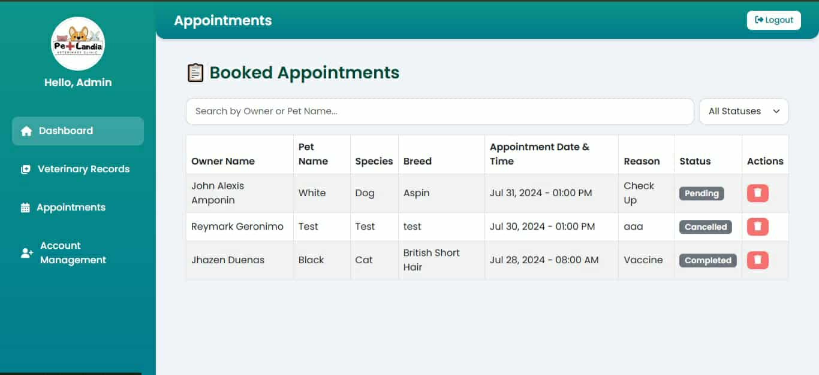4.The Booked Appointments page displays all scheduled appointments between the clinic and pet owners. It includes details such as owner name, pet name, species, breed, appointment date and time, reason for visit, and status. The admin can filter appointments, update their status, or delete them when necessary. This section allows the admin to effectively manage the daily appointment schedule and provide better service to clients.

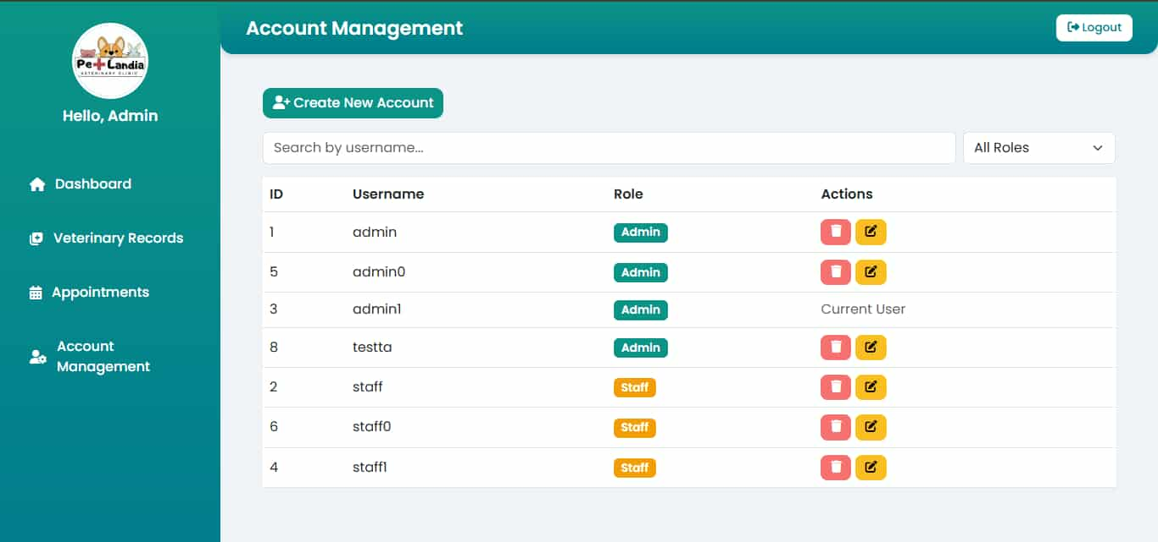5.The Account Management page is designed for handling user accounts within the system. It allows the admin to create, edit, and delete accounts, as well as assign roles such as Admin or Staff. The page includes a search and filter option to easily find users. This feature ensures secure and organized management of all user access and responsibilities within the system.

**Staff Interface Design**

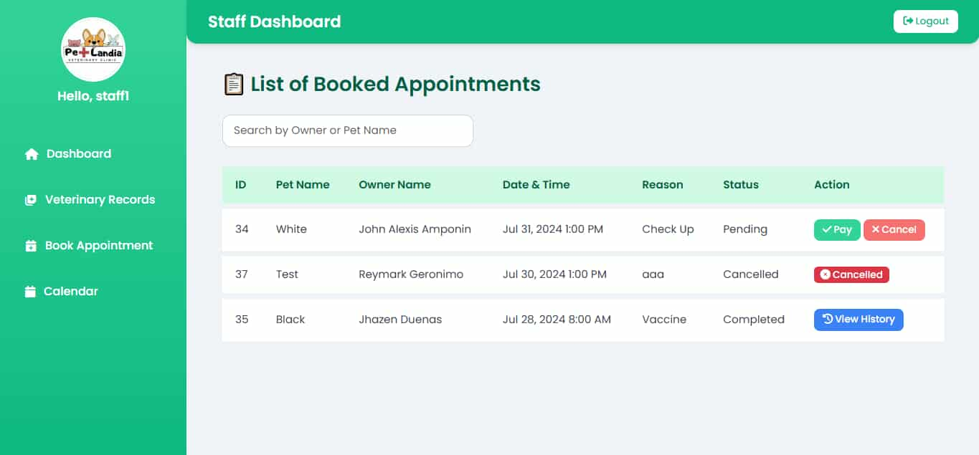1The Staff Dashboard serves as the main control panel for staff members of the Pet Appointment and Veterinary Record System. It allows staff to access essential modules such as the dashboard, veterinary records, appointment booking, and calendar. From here, staff can quickly view and manage daily tasks, track appointments, and monitor pet records, ensuring smooth clinic operations.

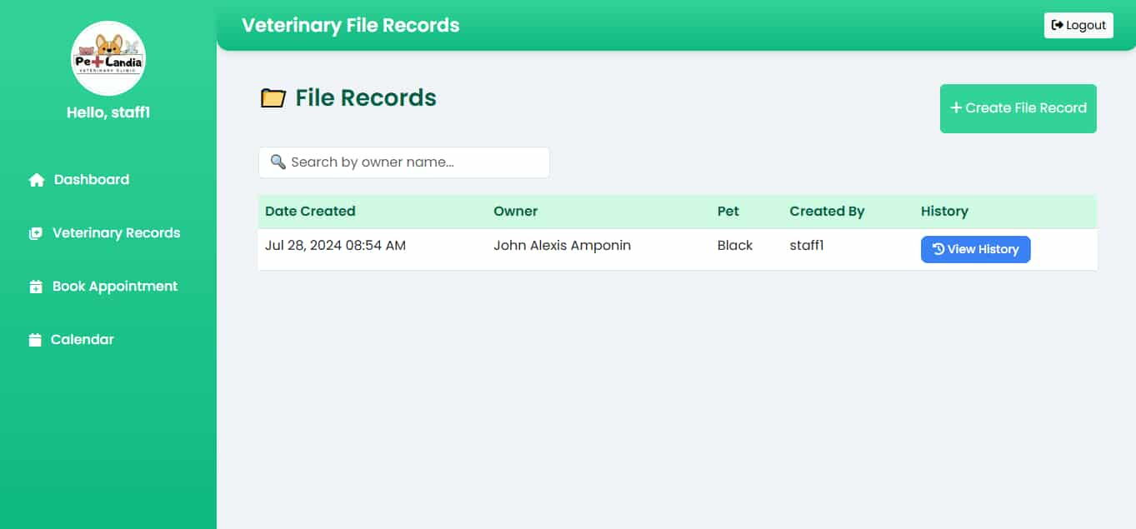2.The Veterinary File Records page allows staff to view and manage existing veterinary records. Each record contains the date created, owner name, pet name, and the staff member who added it. Staff can also search by owner name and open the pet’s medical history. This ensures that pet health records are well-organized, updated, and easily accessible when needed.

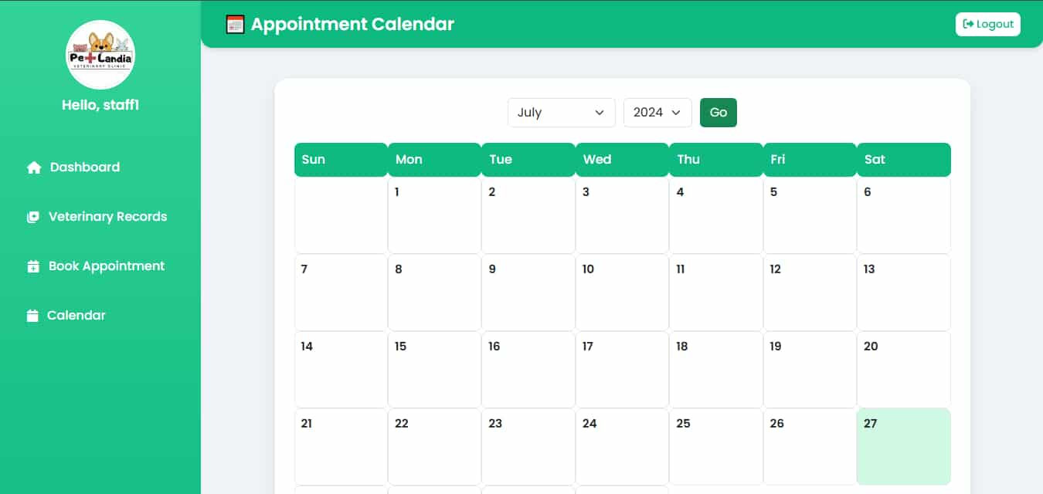3.The Appointment Calendar provides a visual view of all scheduled appointments within a specific month. Staff can select a month and year to view upcoming bookings and manage daily schedules. This feature helps staff efficiently plan and organize appointments, ensuring that no schedules overlap and that all pet visits are properly accommodated.

**Component Design**

Description of Key System Components/Modules:

The Pet Appointment System is divided into several main components that work together to provide a complete solution:

1. Login Module – Only the admin and staff have the right to log in.
2. Dashboard Module – Displays a summary of appointments, pet records, and system activities in one central screen.
3. Appointment Module – The registration of the pet and pet owner..
4. Pet Records Module – Stores information about each pet, including name, species, breed, and age.
5. Owner Records Module – Keeps details of pet owners such as name, address, and contact information.
6. Veterinary Records Module – Maintains health history, treatments, and vaccination records for each pet.
7. User Management Module – Allows administrators to add, edit, or remove staff accounts.

**DATA FLOW DIAGRAMS**

This is the Data Flow Diagram of the Pet Appointment System, it shows how information moves between staff, administrators, and the system’s database. Staff members can check date availability using the calendar, make bookings, and add owner and pet records. They can also view veterinary records and see all booked appointments.

Administrators are responsible for modifying and updating records in the system. They can save changes to veterinary records, appointment records, and account management. All the information is stored in the database so that it remains organized and easy to access. It makes clear on how data flows in the system, showing the connection between staff, admin, and the stored records.

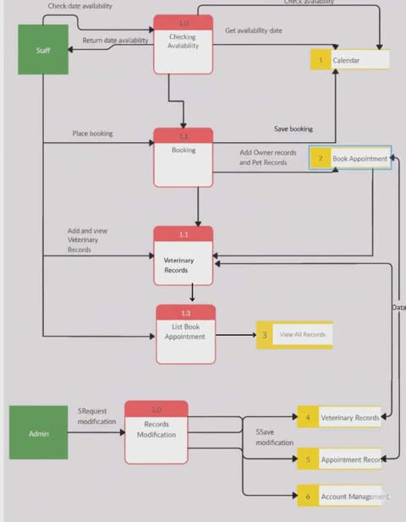

*Figure 2. Data Flow Diagram*

The external entities that interact with the Pet Appointment System are described in this section. While these users exist outside the system boundary, they are essential for triggering and receiving system actions. Pet owners provide pet details and request appointments, while clinic staff and administrators manage schedules, update records, and generate reports. The database stores all the vital information, including owner records, pet records, appointments, and veterinary history. Defining these external entities ensures that all interactions are properly handled and the boundaries of the system are clear.

* **Admin** – manages staff accounts, monitors system settings, and reviews reports
* **Clinic Staff** – handles pet records, owner details, schedules appointments, and confirms requests
* **Pet Owners** – request appointments and register pets

**PERFORMANCE DESIGN**

The goal of this system is to speed up the process of making appointments and sorting records from clients. Another advantage of this system is that it reduces costs or hassles that people may experience, since they no longer need to go directly to the veterinary clinic to set an appointment. For the staff, the benefit is that recording becomes much easier and duplication of client information is avoided. Performance Requirements and Objectives

This system contains simple user interfaces and allows quick creation of records from clients. The expected outcome of the system is to reduce the expenses of visiting the veterinary clinic. It also prevents duplication of information through its simple interface. Even if errors occur, the system is designed not to encounter major problems when handling them.

Strategies for System Optimizing Performance The strategy made by the programmer of this system was to create a database. In it, the programmer designed tables and added information that helps speed up the system being developed. The purpose of this is to sort the information coming from clients without any issues in using the system, while also reducing the hassle of manual appointment setting.

Performance Testing Plan The tester inputs a large amount of information to test the system’s capacity or limit. After testing, the system surprisingly continues to work smoothly. To maintain this performance, the creators will proceed with updates if possible and address errors that clients may encounter while using the system.

**ERROR HANDLING AND LOGGING**

The system will send a user-friendly message that delivers an error notification so users can understand what mistake they made or gain insight and ideas on how to troubleshoot their error, instead of relying on difficult mechanisms or strategies. The strategies and mechanisms created are intended to make error handling easier compared to other systems.

**Error Handling Mechanisms and Strategies.**

Error handling serves as a guide for users on what steps to take after multiple unsuccessful login attempts. It is the message that appears when they try to log in but fail to gain access. This message is intended to help users understand or get an idea of what their error is and how they can troubleshoot the issue they have encountered, not only in the login section

**Logging Requirements and Specifications**

* All of the activities like Veterinary List, Appointment Date, Book Appointment will be recorded.
* Errors and system crashes will be logged for troubleshooting.
* Logs will be stored securely to protect sensitive information’s from clients.

**Error Codes and Message**

|  |  |  |
| --- | --- | --- |
| ERROR CODES | DESCRIPTION | ERROR MESSAGE |
| E101 | Login error wrong password | “Incorrect Password” |
| E202 | Login account error | “User not found” |
| E303 | Veterinary record not found | “Authenticated number not found” |

**THIRD-PARTY INTEGRATION**

To make the Pet Appointment and Veterinary Record Management System more efficient, user-friendly, and easier to maintain, third-party tools and frameworks are integrated into its design. Two of the main integrations used in this system are Bootstrap and Xampp.

**List of Third-Party Services or APIs Integrated into the system**

* Bootstrap are used as a third-party to this system because of the potential to make a quality user interface design, it’s used for developing a system because it has good performance in terms of designing interfaces.
* Xampp are used to provide a complete local server package including Apache, MySQL, PHP, that makes development and testing of the system easier.

**Description of Integration Points and Data Exchange Formats**

Bootstrap CSS and JavaScript libraries are linked into the system’s web pages. Since Bootstrap is a front-end framework, no data exchange is needed. Instead, it interacts with the system’s html structure to style and organize content.

Xampp are used for PHP to handles the back-end logic like appointment schedule and record veterinary records update, and PHP also handles response in formats like Json and Html.

**DEPLOYMENT PLAN**

The deployment Plan of the Pet Appointment and Veterinary Record Management System will follow a proper procedure or process to make sure the system is properly installed, tested, and ready for use by admin, staff and clients. The main goal of this plan is to ensure a smooth process from development to actual use without disrupting Veterinary Clinic operations.

**Overview of the Deployment Process**

The deployment process for the Pet Appointment and Veterinary Record Management System is all about making sure the system is properly set up and ready to be used by the veterinary admin, staff and pet owners. The goal is to introduce the system smoothly, without causing disruptions to daily operations in the clinic.

**Testing Before Deployment**

The Testing Phase is the first step before the deployment, system needs to finalized before we’ll be able to release the system to make sure that is running properly and stable without any disruption for a fully developed system for veterinary clinic, testing before deployment was the first priority for making a quality system.

**System Installation**

Once the testing is complete, the system will be installed on different web-based server or software to finally testing it by clients this system needs will be set up.

**System Monitoring Performance**

After the deployment and installation, the system will be continuing process for making a Pet Appointment and Veterinary Record Management System, the system will under monitoring by developers to make sure that it runs properly and to be ready by unexpected bugs or error during using it by a user.

**Hardware and Software Requirement for Deployment**

**Hardware Requirement**

* Server if local: intel i5 or higher, 8GB RAM or 16 GB RAM, and stable internet.
* Clients, Staff and Admin Devices: Smartphone, Computer, or Laptops with Internet

**Software Requirement**

* Database: XAMPP
* Application: Visual Studio Code
* Programming Environment: PHP

**MAINTENANCE AND SUPPORT**

This Section provide a deeper understanding on how to maintain the system, The purpose of this section was be able to see the different techniques on how to maintain a system that be created, from handling Updates, Patches, and Bugs to fix, and the process on how to resolve issue about the system.

**Guidelines for system maintenance and support**

* Regular System Checking will be performed database cleanup to maintain the stability and good performance of system, the SQL Server needs to cleanup by deleting old information from the clients.
* Update the system for fixing bugs or problem, and get a new feature to maintain the good performance of the system, and update the client’s information to remove old information or duplication of information

**Handling Updates, Patches, and Bugs Fixes**

* Minor updates and patches will be applied monthly
* Major update will employ for emergency or needs an immediately for fixing errors and bugs that affect the process of system,
* System Patch will update and fixes a system problem and resolving bugs, improve the performance of Pet Appointment and Veterinary Record Management System.

**Escalation Process for Resolving Issues**

* Level 1: Analyze and checks issue from Pet Appointment and Veterinary Record Management System to proceed the next step or level.
* Level 2: IT team investigates deeper problem to make sure that all of the problem shows and nothing left, to fix any issues and resolve it by investigating and proceed to the next step or level.
* Level 3: Developer is contacted if the problem requires coding fixes to ensure and resolve the error or bugs that they found in Pet Appointment and Veterinary Record Management System.

**REVISION HISTORY**

This Section provides an information, a revision history of Pet Appointment and Veterinary Record System description, dates, and team to determine the error or see the changes from documents and system, to be more specific and justify what is wrong from document and system, the reason for creating a good documents and system and improve it to become reliable source and a good system.

|  |  |  |
| --- | --- | --- |
| **Date** | **Description** | **Team** |
| 08/12/25 | Major Revision, Introduction to Project Governance | (ALL) |
| 08/19/25 | Order of Headings and Format Changes | (ALL) |
| 08/25/25 | System Function Adding another document | (ALL) |

**APPENDIX**

The goal of creating this system is to build an **offline desktop application** that helps veterinary clinics manage appointments and records more easily. Instead of using paper files, the system allows staff to organize schedules, assessments, and notifications directly on the computer. This reduces errors, saves time, and makes the work process more efficient inside the clinic.

This research has two main objectives: first, to **design and develop a desktop-based appointment and record management system**, and second, to test its usability. The usability test checks if the system is simple to use and if it improves how staff handle appointments compared to the manual method. By doing this, the researchers can measure how helpful and effective the system is for daily clinic operations.

The purpose of this study is also to see how an **offline system** can support veterinary services for companion animals. The system provides tools for managing client and pet records, handling appointments, and keeping veterinary history organized. This research aims to improve veterinary service delivery in the Philippines by giving clinics a reliable, easy-to-use, and secure record management system.

References:

Mohd Yusof, Mas Nur Alya and Mohd Fauzi, Shukor Sanim (2023) *Veterinary clinic management system / Mas Nur Alya Mohd Yusof and Shukor Sanim Mohd Fauzi.* In: Research Exhibition in Mathematics and Computer Sciences (REMACS 5.0). College of Computing, Informatics and Media, UiTM Perlis, pp. 19-20. ISBN 978-629-97934-0-3<https://ir.uitm.edu.my/id/eprint/100149/>

Rosmani, Arifah Fasha and Mokhtar, Muhammad Harith (2023) *An online scheduling platform for veterinary appointments / Arifah Fasha Rosmani and Muhammad Harith Mokhtar.* [Jurnal Intelek](https://ir.uitm.edu.my/view/publication/Jurnal_Intelek.html), 18 (2): 2. pp. 16-26. ISSN 2682-9223

<https://ir.uitm.edu.my/id/eprint/82837/>

PawHub: A Web-based Telehealth Application for Companion-Animal Veterinarians’ Consultation Services

https://dl.acm.org/doi/abs/10.1145/3608251.360828